**OPTIMAL WATER IRRIGATION MODEL FOR INDIAN TOPOLOGY USING ML**

*Project Report submitted in partial*

*fulfillment of the requirement of*

**Bachelor of Technology**

**Prepared by**

|  |  |
| --- | --- |
| LALLITH PRASATH | 20BCE1256 |
| S RISHABH REDDY | 20BCE1545 |
| ADAVELLI ROHAN REDDY | 20BRS1270 |

**Under the guidance of**

Dr. S GANAPATHY

**CSE1901**

**(TECHNICAL ANSWERS TO REAL WORLD PROBLEMS)**



**VELLORE INSTITUTE OF TECHNOLOGY, CHENNAI**

**CERTIFICATE**

# This is to certify that this project entitled “**OPTIMAL WATER IRRIGATION MODEL FOR INDIAN TOPOLOGY USING ML MODELS**” submitted in partial fulfilment of the degree of B. Tech to Vellore Institute of Technology, Chennai, done by **LALLITH PRASATH** (**20BCE1256), S RISHABH REDDY (20BCE1545), ADAVELLI ROHAN REDDY (20BRS1270)** is an authentic work carried out by they/them under my guidance. The matter embodied in this project work has not been submitted earlier for award of any degree or diploma to the best of my knowledge and belief.

# **Lallith Prasath**

**S Rishabh Reddy**

**Adavelli Rohan Reddy**

# *Date:* ***14th April 2023***

# **DECLARATION BY THE STUDENT**

We, **Lallith Prasath, S Rishabh Reddy, Adavelli Rohan Reddy,,** bearing Reg. No. **20BCE1256, 20BCE1545, 20BRS1270** hereby declare that this project report entitled **OPTIMAL WATER IRRIGATION MODEL FOR INDIAN TOPOLOGY USING ML MODELS** has been prepared by me towards the partial fulfilment of the requirement for the award of the Bachelor of Technology (B. Tech) Degree under the guidance of **Dr. S. Ganapathy**

I also declare that this project report is my original work and has not been previously submitted for the award of any Degree, Diploma, Fellowship, or other similar titles.

Place: Chennai

Date: 14th April 2023

# LALLITH PRASATH (20BCE1256)

# S RISHABH REDDY (20BCE1545)

# ADAVELLI ROHAN REDDY (20BRS1270)

# 

# 

**ABSTRACT**

Effective irrigation methods are crucial for agriculture, and accurately estimating evapotranspiration is essential for determining water requirements. However, the current state-of-the-art method, the Modified Penman, requires expensive parameter calculations, which may not be accessible to all farmers or regions. To address this issue, we propose a modified Hargreaves model to estimate evapotranspiration, which requires fewer parameters, making it more cost-effective and accessible. The proposed model includes crop evapotranspiration calculations for major crops during different growth stages, which improves the accuracy of irrigation needs estimations. The study utilizes data from Climwat 2.0 and Cropwat 8.0, which consists of Region Station, Month, Minimum Temperature, Maximum Temperature, Humidity, Wind km/day, Sun hours, Rad MJ/m^2/day, ETo mm/day, and Soil Types. The performance of the modified Hargreaves model was evaluated using RMSE, MSE, and MAE metrics. To test the accuracy of the dataset, linear regression and random forest analysis were performed. Our results demonstrate that the modified Hargreaves model is a cost-effective and accurate alternative to the Modified Penman method for estimating evapotranspiration. Overall, our proposed modified Hargreaves model provides an efficient and cost-effective method for estimating evapotranspiration, which can help improve irrigation practices. Additionally, the inclusion of crop evapotranspiration calculations for major crops during different growth stages adds further value to the proposed model.

**ACKNOWLEDGEMENT**

We are using this opportunity to express our gratitude to everyone who supported us throughout the course of this project. It is not possible to prepare a project report without the assistance and encouragement of other people. This one is certainly no exception. On the very outset of this report, we would like to extend our sincere & heartfelt obligation towards all the personages who have helped us in this endeavour. Without their active guidance, help, cooperation & encouragement, we would not have made headway in the project. We are ineffably indebted to our faculty Dr. S. Ganapathy for his conscientious guidance and encouragement to accomplish this assignment presently. We extend our gratitude to VIT Chennai for giving us this opportunity. We also acknowledge with a deep sense of reverence, our gratitude towards our parents and members of our family, who have always supported us morally as well as economically.

At last, but not least gratitude goes to all of our friends who directly or indirectly helped us to complete this project report. Any emission in this brief acknowledgement does not mean lack of gratitude.

**CONTENTS**

1. **INTRODUCTION 7**
2. **REVIEW OF LITERATURE 8**
3. **PROPOSED WORK 11**

3.1 Background 11

3.2 Dataset Description 12

3.3 Proposed Model 13

3.4 Experimental Setup 15

1. **SYSTEM ARCHITECTURE 16**

4.1 Application Architecture 16

4.2 Use Case Diagram 17

1. **CODE AND UI 18**

5.1 Model Building 18

5.2 User Interface 19

5.3 UI Backend 21

1. **RESULTS AND DISCUSSION 23**

6.1 Evaluation Parameters 23

6.2 Experimental Results 25

6.3 Model Testing 27

1. **CONCLUSION AND FUTURE WORKS 41**
2. **REFERENCES 42**
3. **MANUAL WORKFLOW 44**

1. **INTRODUCTION**

Water is a scarce resource, and its effective management is critical for sustainable agriculture. Irrigation is essential for crop growth, but it must be carefully balanced to avoid water waste and environmental damage. Estimating evapotranspiration is a critical step in optimizing irrigation, as it helps determine the amount of water needed for crops.

The Modified Penman method is currently the most accurate method for estimating evapotranspiration. However, it requires complex and expensive calculations that may not be feasible for all farmers or regions. To address this issue, a modified Hargreaves model has been proposed, which is a simplified version of the Penman method that requires fewer parameters, making it more accessible and cost-effective.

The Hargreaves model uses temperature and radiation data to estimate evapotranspiration, which makes it easier to use in areas where data on other parameters are not readily available. The modified Hargreaves model further simplifies the calculations, reducing the number of required parameters while maintaining a high level of accuracy.

In addition to the modified Hargreaves model, this study also includes crop evapotranspiration calculations for major crops during different growth stages. These calculations provide more accurate estimations of irrigation needs, helping farmers optimize water usage and improve crop yields.

To evaluate the accuracy of the proposed model, the study utilizes data from Climwat 2.0 and Cropwat 8.0, which includes various climatic parameters such as temperature, humidity, wind, and radiation. Performance metrics such as RMSE, MSE, and MAE were used to assess the accuracy of the model, and linear regression and random forest analysis were conducted to test the accuracy of the dataset.

The results of the study demonstrate that the modified Hargreaves model is a cost-effective and accurate alternative to the Modified Penman method for estimating evapotranspiration. The inclusion of crop evapotranspiration calculations for major crops during different growth stages adds further value to the proposed model, making it more relevant and useful for practical applications.

Overall, the proposed modified Hargreaves model offers a cost-effective and efficient method for estimating evapotranspiration, providing accurate estimations for irrigation needs. The model's simplicity and reduced parameter requirements make it more accessible to farmers and regions with limited resources, promoting sustainable irrigation practices and water conservation.

1. **REVIEW OF LITERATURE**

Juan Torres-Batlló, et al. (2019) explores the reasons for the shrinking of Lake Poopó. Trends in ETo and vegetation of the lake have been mapped using remote sensing data and the findings state the reduction in lake water is due to decline in precipitation and vegetation. The paper can be further tested with other regions.

R. B. Singandhupe, et al. (2017) compares different ETo models to estimate water requirements in semi-arid regions for crops. The findings of the paper provide information on a more informed water management practice. The paper can be continued by calculating the water requirements for different stages of crop growth.

Wei Meng, et al. (2019) calculates the ETo of trees in water storage pit irrigation systems in the Loess Plateau region of China. The findings can be used to make informed decisions on design and operations of the systems. Taking this paper as a base we can scale up to multiple regions.

Bita Khodayvandie, et al. (2022) proposes an approach to improve the accuracy of ETo estimation in semi-arid regions. The approach taken can be used in other regions. The proposed method requires validation to know its effectiveness.

Lei Zhang, et al. (2018) proposes a method using Kc-ETo to forecast daily crop ETo. This approach can provide inferences on improved water usage efficiency. The proposed model can be integrated with precise agricultural technologies to be more accurate.

Yufeng Luoa, et al., (2014) propose a technique to predict the ET0 by utilizing temperature forecasts and a calibrated Hargreaves-Samani model. This approach forecasts the ET0 for a 7-day horizon by implementing the HS model and temperature data. The paper can be improved by collecting more accurate weather data.

Liu Mei-Xian, et al., (2012) propose an approach to study the impact of water quality in drip irrigation and the layout of drip tape on soil salinity is investigated. This approach reduces salt accumulation in the roots and maintains a crop yield with low-quality irrigation water. Further studies are needed to analyze the sustainability of saline water for long periods of time in the area.

Antonio Berti, et al., (2014) studies the possibility for measuring the Hargreaves equation in the Veneto region based on different criteria. The equation obtained from the study was recommended as the standard equation for calculating the reference evapotranspiration. The paper can be further tested with other regions.

Valiantzas J.D, et al. (2013) propose a new algebraic expression to calculate the reference crop evapotranspiration (ET0). The expression was tested and it performed better than existing formulas, including the ones which have limited data inputs. Taking this paper as a base we can scale up to multiple regions and test the expression by adding new features.

Sivaprakasam Subburayan, et al. (2011) examine and calibrate the original Hargreaves equation for a humid and hot location in Tamil Nādu. The original Hargreaves equation underestimated the ETo in humid and hot locations which meant the Hargreaves exponent to change to 0.653 to yield better results. Extensive research has to be done to assess the validity of the proposed equation.

Price J. C. et al. (1990) presents us with a method to calculate the ETO using satellite-derived surface temperature and a vegetation index computed from visible and near-infrared data. The method acquires knowledge that isn't accurately known in many areas due to rapid change of vegetation, lack of data etc. This requires the independent estimate of ETO for a vegetated and non-vegetated area, and the spatial variability in the satellite data. Furthermore, they need a data bank to include more parameters such as surface roughness, moisture etc.

Kumar N et al. (2020) presents us with the use of neural networks for estimating reference ETOin the western Himalayan region using meteorological data. Two NN models were developed with two different inputs and were calculated. It shows that both NN models can be used for effective calculation of ETO.

Price J. C. et al. (1982) highlights the use of thermal-infrared data for calculation ETO on a regional scale. This paper suggests that remote sensing data can provide valuable information on moisture fluxes. For further research, they need to cover areas with frequent cloud cover. This paper also shows the usefulness of NOAA satellite radiometers, helps us get more data and enhance our ability to access moisture condition at the earth's surface

Jackson R D et al. (1985) uses the remote sensing techniques for the estimation of ETO. This paper describes the use of thermal infrared data acquired by satellite systems and the benefits of using remote sensors. Also discuss ETO on a local and regional scale. Local scale relies on airborne remote sensors while regional scale uses satellite data. Further research is needed to establish the quality and utility of the results in areas with frequent cloud cover.

Bennis I. et al. (2015) presents a model architecture for a drip irrigation that uses wireless sensor and actuators network to monitor soil moisture, temperature and pressure sensors. The model differentiates between two main traffic levels transmitted by WSANs to ensure high QoS performance. Results showed promising outcomes in terms of delay and Packet Delivery Ratio for priority traffic, with plans for future real test-bed investigations.

M. Angaleeswari et al. (2021) deals with the computation of crop coefficient values of paddy under drip irrigation by logged volumetric water content by estimating crop evapotranspiration (soil moisture sensors in the fields) using an inverse soil water flow model based on Richards’ equation, validated by mass balance analysis. The developed model matched well during the initial stages but showed nearly 7% higher values in later stages with water balance error estimated as 8%. This paper can be used to determine crop coefficient values in local climatic conditions.

Xin Han et al. (2021) produced a new method for crop ETo prediction by considering the changes in dynamic crop coefficient and precipitation effect in a back-propagation neural network model which was more accurate with the growth status of the crop in real time weather with precipitation, which also took many other factors into consideration. This paper can be used to provide a scientific basis for ETc with respect to growth status of the crop.

Biljana Petković et al. (2020) proposed a model for ETo estimation built using regression based on neuro-fuzzy logic which is able to handle high nonlinearity between data pairs of input and output. The input combinations based on RMSE values obtained in the training phase were taken (average temperature and radiation were the optimal combination for ETo estimation to substitute for the lack of accurate measurements for calculation of ETo). This paper can be further tested in other regions.

Ahmed Elbeltagi et al (2022) proposed a model to estimate ETo using artificial neural networks with the limited available meteorological data in regions of eastern Hungary. The ANN models promoted the decision-making process for the farmers in case there was a lack of climate data (temperature, radiation, wind speed, etc.,) which gives good performance. This paper can be tested for different scenarios with varying datasets to find the most suitable variables for the hidden layers.

Long Zhao et al. (2021) proposed the use of four principal component analysis methods to find which meteorological factors strongly affected the ETo value by a model built on SVM and GBDT. The highest accuracy was observed when the top five factors were extracted using the PA algorithm given as inputs. Artificial bee colony and cuckoo search algorithms were used to further optimize the SVM model, thus resulting in higher accuracies and reduced error rates. Extensive research has to be done to assess the validity of the proposed equation.

1. **PROPOSED WORK**
   1. **Background**

Water is moved from the ground to the atmosphere through evapotranspiration. It is a process that combines transpiration, which is the release of water vapour from plants through the pores in their leaves, with evaporation, which is the conversion of liquid water into water vapour. The water cycle on Earth, which is crucial for controlling the planet's temperature and sustaining varied ecosystems, includes evapotranspiration as a key element. It is the main process by which water is returned to the atmosphere from the ground surface and is in charge of a sizable portion of the moisture in the atmosphere.

Temperature, humidity, wind speed, solar radiation, soil moisture, and plant cover are some of the variables that affect how much evapotranspiration happens in a given location. For instance, evapotranspiration rates are normally high in hot, dry circumstances whereas they are lower in cold, humid settings. In agriculture, evapotranspiration plays a significant role since it influences crop development and output. Farmers may adjust irrigation schedules and other water management techniques to increase crop output by being aware of the variables that affect evapotranspiration rates.

Knowing evapotranspiration rates may aid water managers in better resource allocation, drought and flood planning, and availability prediction. There are multiple models to predict evapotranspiration like *Reference evapotranspiration FAO56, Modified Penman method, Hargreaves method, Radiation method, Blaney Criddle method* and *Pan evaporation method*. Of the above-mentioned methods, Modified Penman is the most accurate and provides highly desirable results. The main drawback of this method is that the parameters required to calculate evapotranspiration through this method are very extensive and require costly sensors. Among the other methods, the Hargreave model considers lesser parameters like extra-terrestrial radiation and temperature. Generally, Hargreaves model is not preferred as its estimated evapotranspiration values are not accurate enough and the root mean square generally is very high.

Most of the researches on estimated evapotranspiration calculation are focused on only one particular type of regions like semi-arid, tropical which on scaling up will be less accurate. After calculating the estimated evapotranspiration, the work can further be continued to calculate the Etc (crop evapotranspiration). ETc is the actual amount of water that the crop uses during the evaporation and transpiration processes. In order to calculate it, you must first measure the amount of water that evaporates from the soil's surface and the amount of water that seeps through the crop's leaves. Next you must sum these two figures. ETc is the quantity of water that a crop may theoretically consume in its ideal growth environment, provided that there is an endless supply of water.

There is heavy emphasis on cost cutting in India, especially in the agricultural sector, so we in our work would like to propose a modified Hargreave model which is more accurate. This would be very helpful to cultivators as collecting all the parameters required to calculate evapotranspiration via Modified Penman would require high upfront costs and setup. Whereas modified Hargreave would still require a lesser number of parameters and provide estimated evapotranspiration values with improved accuracy. Instead of focusing on one particular type of region our paper considers all agricultural stations spanning across India. The calculated root mean squared value for evapotranspiration using the traditional Hargreave method was a negative integer. This shows that the formula requires a suitable intercept to improve its accuracy. Our proposed model will have added intercepts grouped by their soil type like laterite, red, ferralitic, alluvial etc. Further, taking the estimated evapotranspiration and crop factor of various crops that are grown majorly in India like paddy, maize, wheat etc, we would calculate the crop evapotranspiration. Etc is calculated for different stages of the crop growth for providing optimal water usage. The cultivators thus can provide crops with optimal amounts of water required for healthy growth during different stages while also emphasizing on water management.

ETc = Kc * ETo

Where,

Etc = Crop evapotranspiration

Kc = crop coefficient

ETo = reference evapotranspiration

* 1. **Dataset Description:**

The dataset used in our research is taken from CLIMWAT 2.0 for CROPWAT (a joint publication of the Water Development and Management Unit and the Climate Change and Bioenergy Unit of Food and Agriculture Organization of the United Nations).

It is an extensive climatic database consisting of more than 5,000 stations worldwide which is directly linked to the irrigation model AQUACROP which allows users to calculate crop water requirements, irrigation supply and irrigation scheduling for various crops for a range of climatological stations.

The following attributes can be observed in the dataset taken from CLIMWAT 2.0 with the addition of major soil type found in each of the regions taken for the study to improve the accuracy of the ETo calculation with the Hargreaves method. (Dataset -1):

● Region Station: One among the 167 local stations distributed across India where agriculture is majorly practiced.

● Month: The particular month the following values below are observed.

● Min Temp: The minimum air temperature recorded in the region station in the particular month in degrees Centigrade.

● Max Temp: The maximum air temperature recorded in the region station in the particular month in degrees Centigrade.

● Humidity: The percentage of water vapor in the air in the region station.

● Wind km/day: The speed of wind calculated in terms of kilometres per day.

● Sun hours: The total time in hours sunlight is available in the region station.

● Rad MJ/m²/day: Value of solar radiation calculated in terms of megajoules per meter square per day.

● ETo mm/day: Evapotranspiration value calculated by the modified Penman method.

● Soil Type: The major type of agricultural soil found in the region station.

Dataset - 2: Crop - Major crops grown across India

The crop evapotranspiration values for different stages of a crop growth:

1.Initial - The mitotic division of meristematic cells present at the root and shoot apex increases the length of the plant body. This is called the initial growth

2.Vegetation - The earlier growth of plants producing leaves, stems and branches without flowers is called ‘vegetative growth’/ Phase.

3.Reproduction - After the vegetative growth, plants produce flowers which are the reproductive part of the plant. This is called reproductive growth/phase.

4.Final - The stationary phase is also referred to as an final steady state of the growth. Growth slows down because of the limiting of nutrients. All the physiological activities of the cells slow down.

* 1. **Proposed Model**

One of our main objectives is to reduce the cost required by farmers to calculate evapotranspiration value of their soil which in turn would help in calculating the optimal amount of water required by crops. The most accurate model is the Modified Penman which requires parameters that are not easy to obtain. So, we would like to take the Hargreave model which is more cost efficient and modify it in such a way as to get the values as close as possible to the Modified Penman model.

Using the CLIMWAT 2.0 and CROPWAT 8.0 tools, gather the parameters needed for the Hargreave model.

Include a new soil type parameter in the dataset.

Compute the classic Hargreaves model's predicted evapotranspiration.

Identify the ETo values that differ between the Hargreave and Modified Penman models, and then add those values to a new column in the dataset.

Get the mean difference for each soil type after grouping the characteristics by soil type.

The conventional Hargreave equation may be made more appropriate for Indian agricultural production by using the mean as an intercept.

For each main soil type, we now have a modified Hargreave equation.

Modified Hargreave Equation,

ETo=0.0023 Ra(TC+17.8)TR^0.5+ 1.988 (Black)

= 0.0023 Ra(TC+17.8)TR^0.5+ 1.72 (Red)

= 0.0023 Ra(TC+17.8)TR^0.5+ 1.707 (Alluvial)

= 0.0023 Ra(TC+17.8)TR^0.5+ 1.959 (Sandy)

= 0.0023 Ra(TC+17.8)TR^0.5+ 1.979 (Laterite)

Where,

ETo= reference evapotranspiration (mm/day)

Ra= extra-terrestrial radiation (mm/day)

TR= Tmax -Tmin (°C)

TC= mean temperature (°C);

mean temperature = ((Tmax -Tmin))⁄ 2 °C)

Gradient Descent, which is an algorithm that approaches the least squared regression line via minimizing sum of squared errors through multiple iterations, is best suited for us to achieve our objective. So in our work, we grouped the dataset by soil type and then using gradient descent, best slope and intercepts of Hargrave models were calculated.

Using the gradient descent model when the soil type is not mentioned,

Modified ETo = 1.725*ETo - 0.037

where ETo is the value obtained from the traditional Hargreaves model.

**3.4** **Experimental Setup**

Dataset:

Data is extracted from tools CLIMWAT 2.0 and CROPWAT 8.0 for a total of 167 agricultural region stations across India.

Software Requirements:

* Software language: Python
* Development environment: VS Code, Jupyter notebook or Google Collab
* Internet browser: Google chrome (or) Mozilla Firefox

Hardware Requirements:

* Processor: Intel Pentium or more
* Ram: 128mb or more
* Hard disk: 4gb or more
* Cache: Minimum of 512kb
* Internet connection

1. **SYSTEM ARCHITECTURE**

**4.1 Application Architecture Diagram**

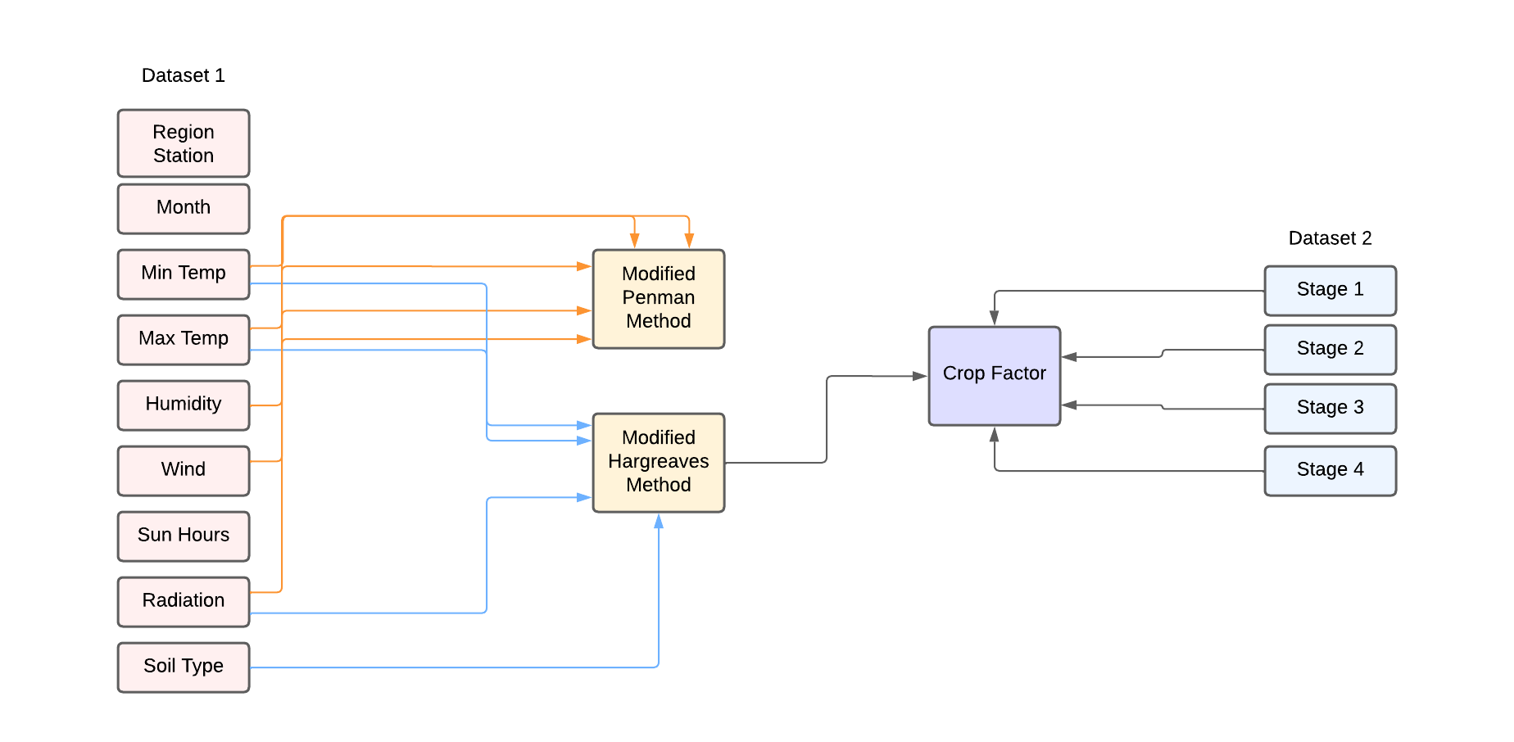

The model used consists of data taken from Climwat 2.0 and Cropwat 8.0. The dataset consists of Region Station, Month, Minimum Temperature, Maximum Temperature, Humidity, Wind km/day, Sun hours, Rad MJ/m^2/day, ETo mm/day and Soil Types. The model is first evaluated using the Traditional Hargreaves method and the Penman method. Next Minimum Temperature, Maximum Temperature, Radiation and Soil Type along with Crop factor are used to evaluate the newly identified equation known as the Modified Hargreaves Method. The Crop factor is evaluated by considering all the stages of growth of the crop present in another dataset. Finally, the Minimum Temperature, Maximum Temperature, Humidity, Wind and Radiation are used to evaluate the Modified Penman Method.

**4.2 Use Case Diagram**

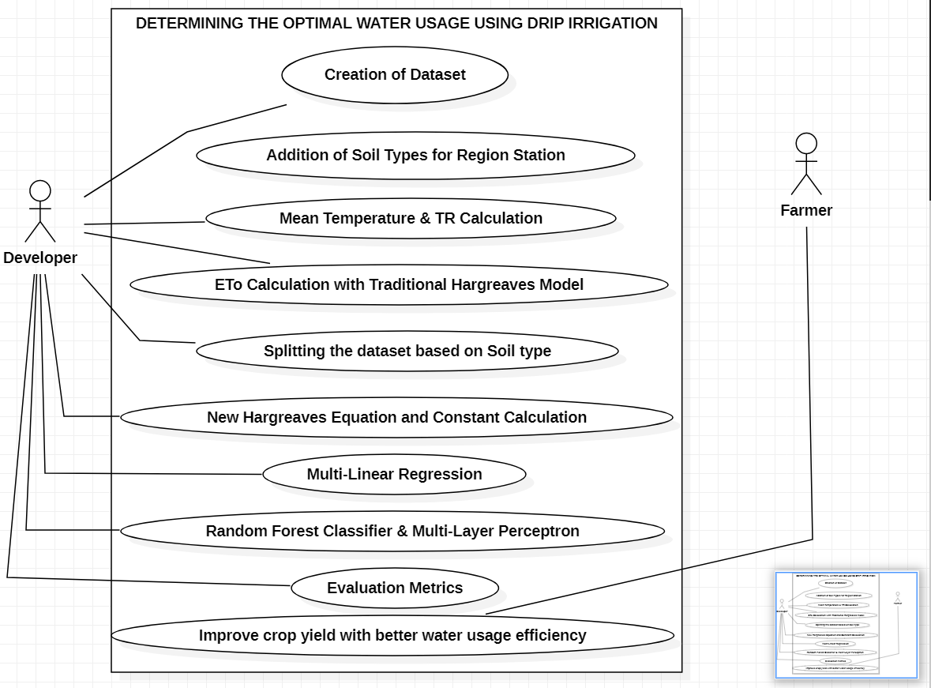

To begin with, we first created a comprehensive dataset by including information on soil types for different regions and stations. We then computed the mean temperature and TR values and used these to determine the ETo (evapotranspiration) through the Traditional Hargreaves Method.

In order to enhance the accuracy of our analysis, we segmented the dataset based on soil types. After splitting the data, we utilized the New Modified Hargreaves Method to calculate the ETo. We then leveraged various machine learning algorithms, such as Multi-Linear Regression, Random Forest Classifier, Multi-Layer Perceptron, and Gradient Descent, to further refine our results. These models enabled us to perform rigorous evaluation metrics and assess the effectiveness of our analysis.

In conclusion, our analysis has helped us to improve crop yield and enhance water usage efficiency by generating detailed insights into soil types, temperature, and evapotranspiration. By leveraging advanced techniques like machine learning, we were able to generate more accurate predictions and improve our understanding of how different factors impact crop yield. The results of this study have the potential to inform and guide agricultural practices, thereby leading to more sustainable and productive outcomes.

1. **CODE AND UI**

**5.1 Model Building**

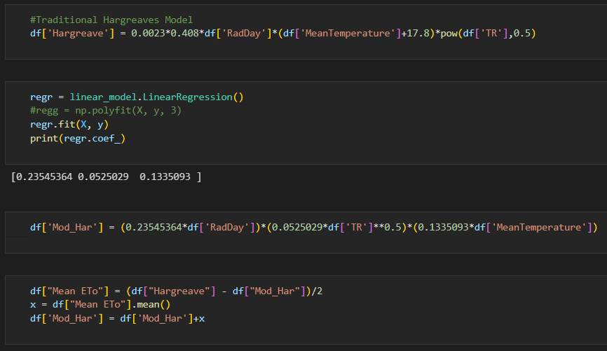

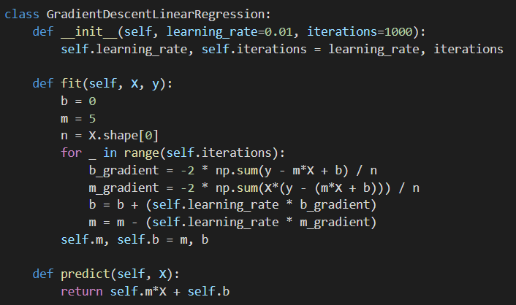

**5.2 User Interface**

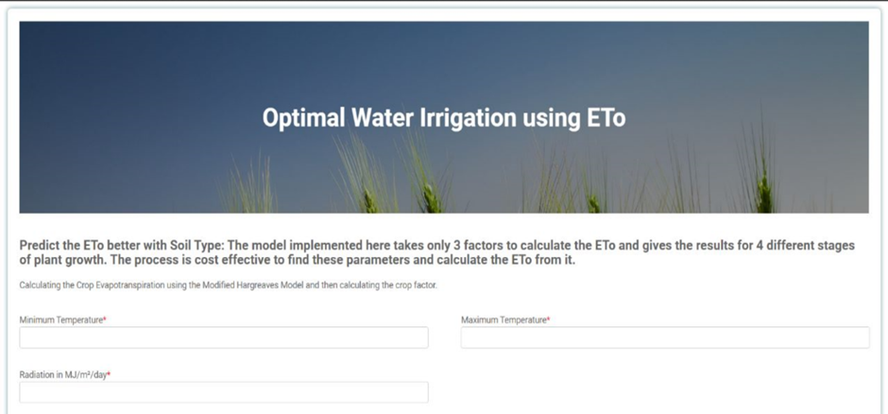

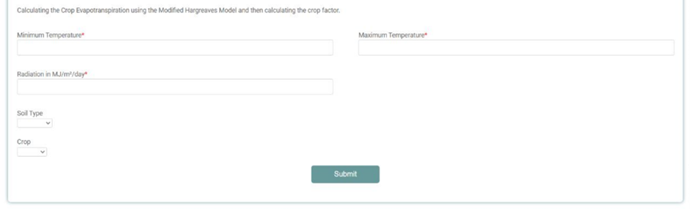

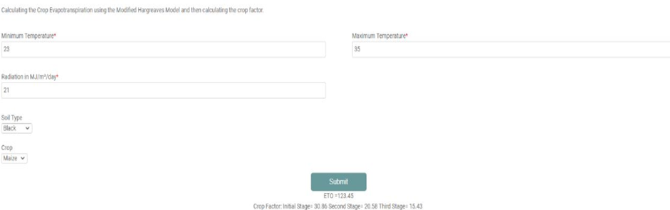

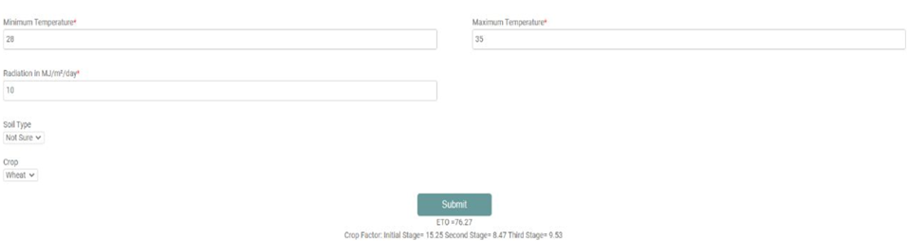

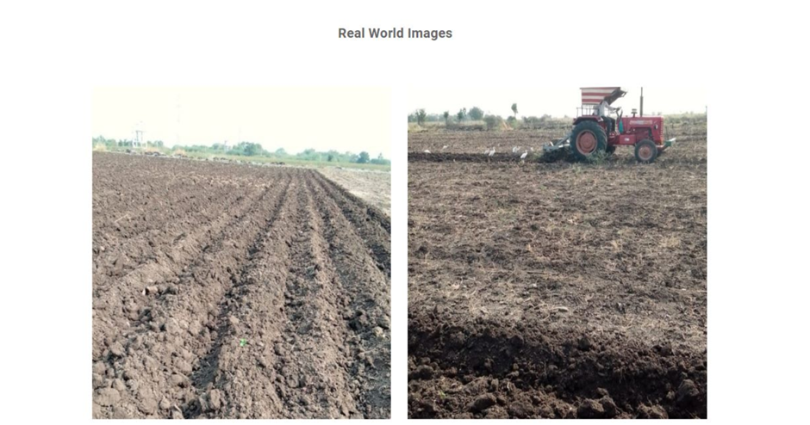

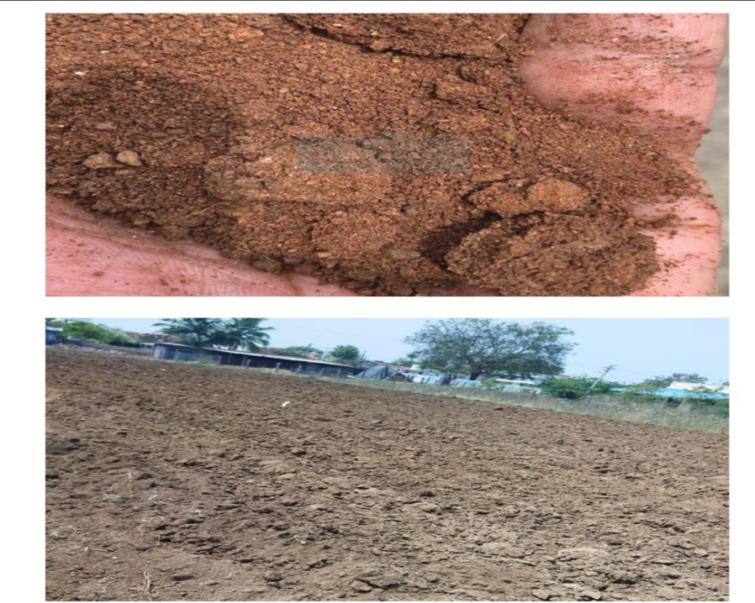

**5.3 UI Backend**

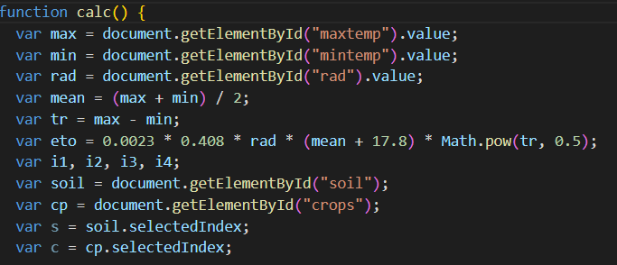

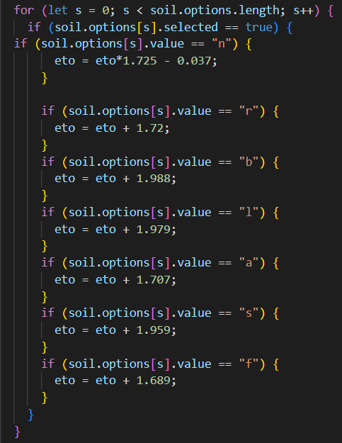

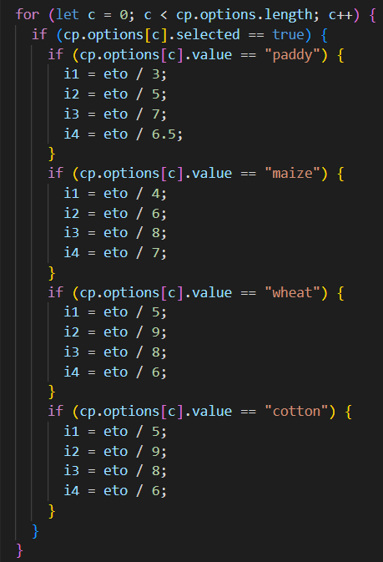

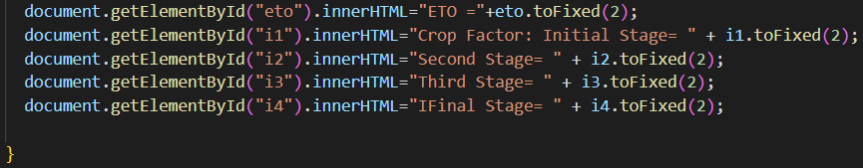

1. **RESULT AND DISCUSSION**
   1. **Evaluation Parameters:**

**Accuracy** - It is the percentage of correct predictions made by a model. It is calculated by dividing the total occurrences of correct predictions by the total occurrences of the predictions made. Accuracy is critical for the project as it ensures efficient water usage, promotes crop health, and minimizes environmental impact.

Accuracy = $\frac{TP+FP}{TP+FP+FN+TN}$

**Precision** - It is the correct positive predictions made by a model. It is evaluated by dividing the number of true positive predictions by the total number of positive predictions made in the model. Precision ensures the model has accurate data, improved decision making and cost-effectiveness.

Precision = $\frac{TP}{\left(TP+FP\right)}$

**Recall** - Recall measures the percentage of actual positives which are correctly identified by the model. It is evaluated by dividing the number of true positive predictions by the total number of actual positive cases. Recall helps in identifying inefficiencies, reduces costs, and promotes positive environmental change.

Recall = $\frac{TP}{\left(TP+FN\right)}$

**F1-Score** - It is a measure which combines precision and recall into a single metric. It is evaluated as the harmonic mean of both precision and recall, which results in equal weightage to both metrics. It is an important metric which evaluates the performance of the model and determines the effectiveness in optimizing water usage.

F1 - Score = $\frac{2*\left(Precision*Recall\right)}{Precision+Recall}$

**MAE -** Mean squared error (MSE) measures the amount of error in statistical models. It assesses the average squared difference between the observed and [predicted values](https://statisticsbyjim.com/glossary/fitted-values/).

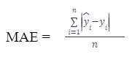

**MSE -** It tells you how close a regression line is to a set of points. It does this by taking the distances from the points to the regression line (these distances are the “errors”) and squaring them

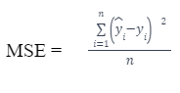

**RMSE -** It is a statistical measure used to evaluate the accuracy of a prediction by comparing the difference between the predicted and actual values.It is calculated by taking the square root of the average of the squared differences between the predicted and actual values.

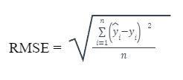

**R-SQUARED -** It is a statistical measure in a regression model that determines the proportion of variance in the dependent variable that can be explained by the [independent variable](https://corporatefinanceinstitute.com/resources/knowledge/modeling/independent-variable/).

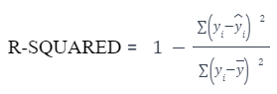

* 1. **Experimental Results:**

The following are the experimental results when performed using the traditional Hargreaves formula:

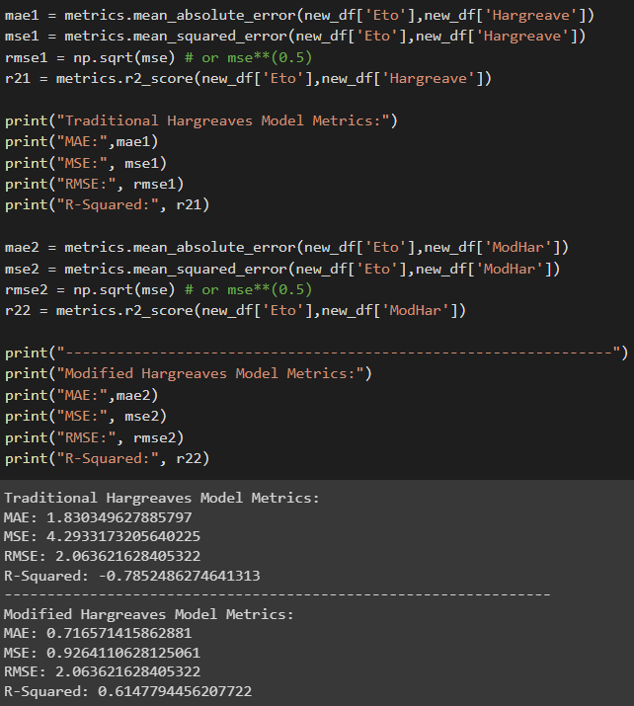

The following are the results for modified Hargreaves equation:

For alluvial soil:

MAE: 0.7164306172821961

MSE: 0.9337360487084262

RMSE: 0.9663001856092268

R-Squared: 0.5995511893415958

For black soil:

MAE: 0.7918985725510465

MSE: 1.0917378117713878

RMSE: 1.0448625803288143

R-Squared: 0.5747639609079175

For red soil:

MAE: 0.579185301697455

MSE: 0.5629021953379086

RMSE: 0.750268082313188

R-Squared: 0.6728083464054782

For sandy soil:

MAE: 0.8719667497335597

MSE: 1.3416182766097506

RMSE: 1.1582824684030018

R-Squared: 0.6060605609206919

For laterite soil:

MAE: 0.6641344485653276

MSE: 0.8631026592157957

RMSE: 0.9290331852069632

R-Squared: 0.6082219699561924

**6.3. Model Testing:**

Mean Regression Model:

Split Ratio = 0.2

Linear Regression:

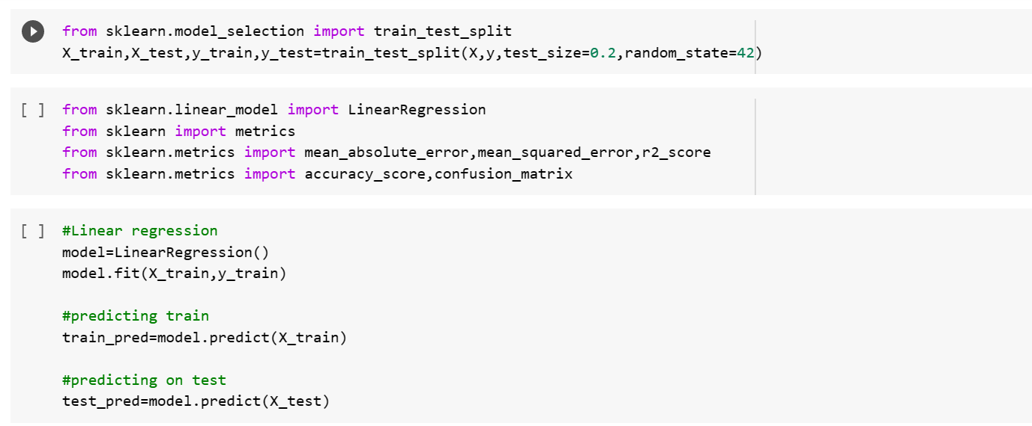

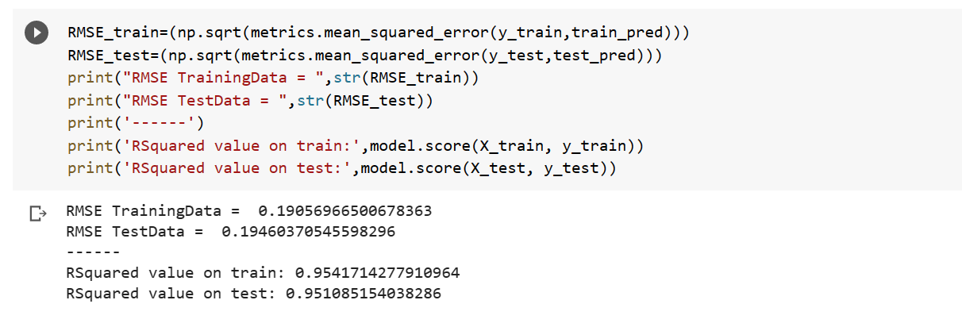

Random Forest:

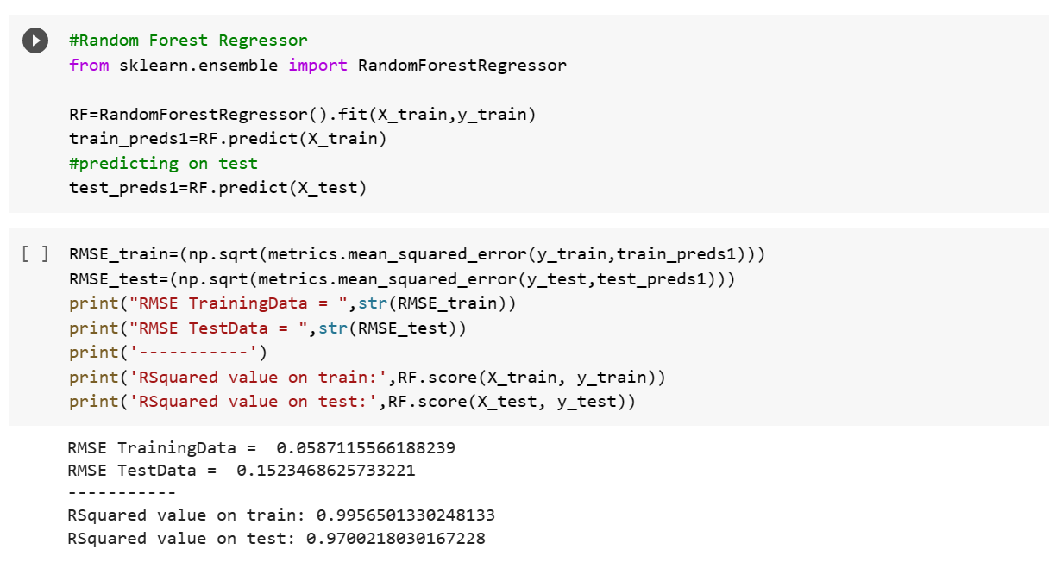

Split Ratio=0.4

Linear Regression:

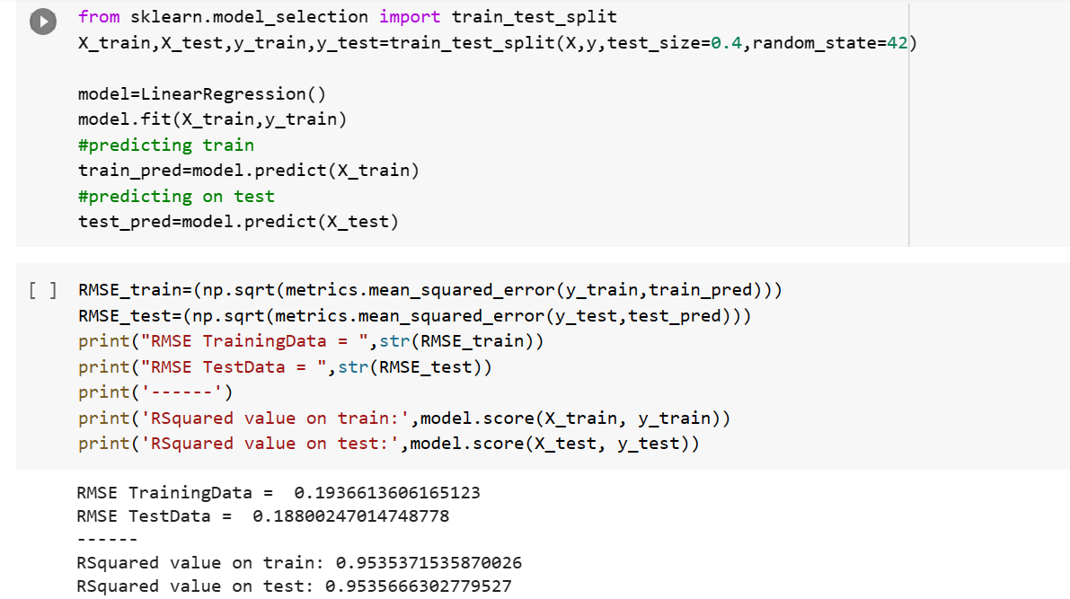

Random Forest:

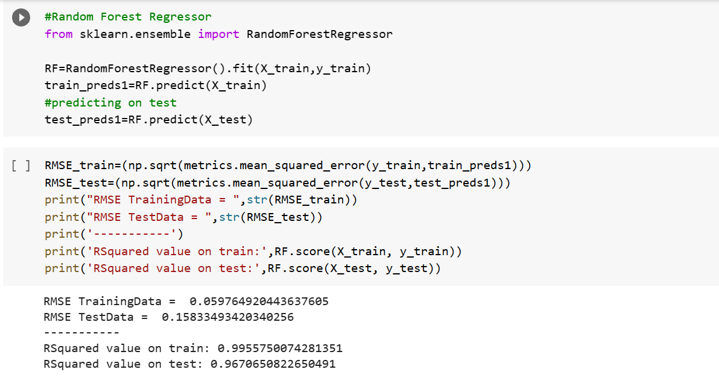

Split Ratio=0.6

Linear Regression:

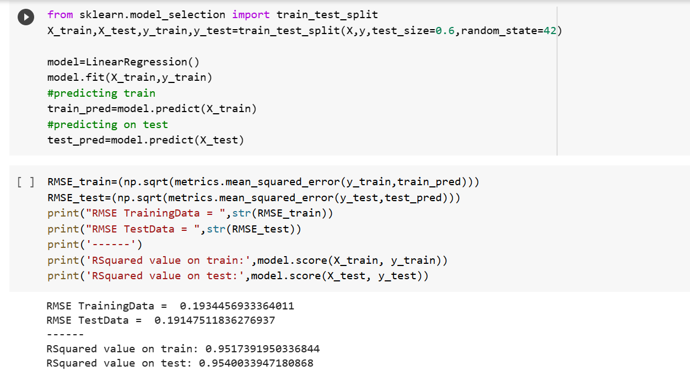

Random Forest:

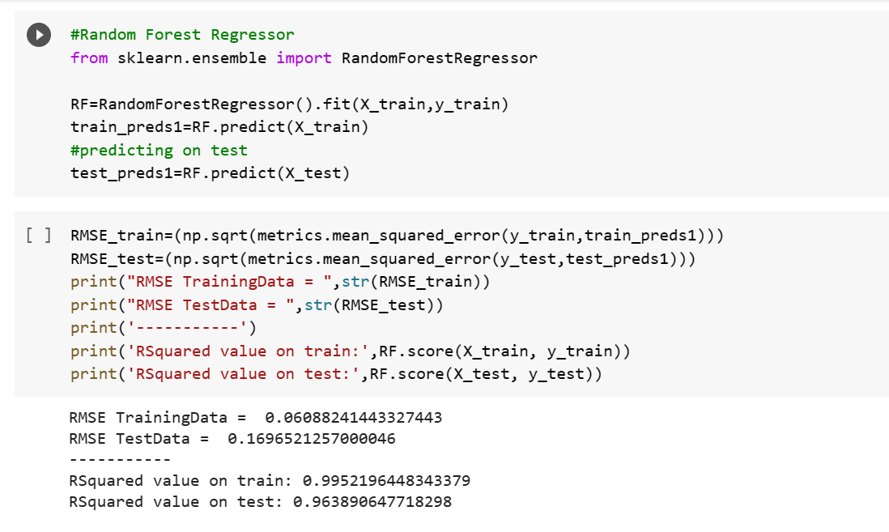

Split Ratio=0.75

Linear Regression:

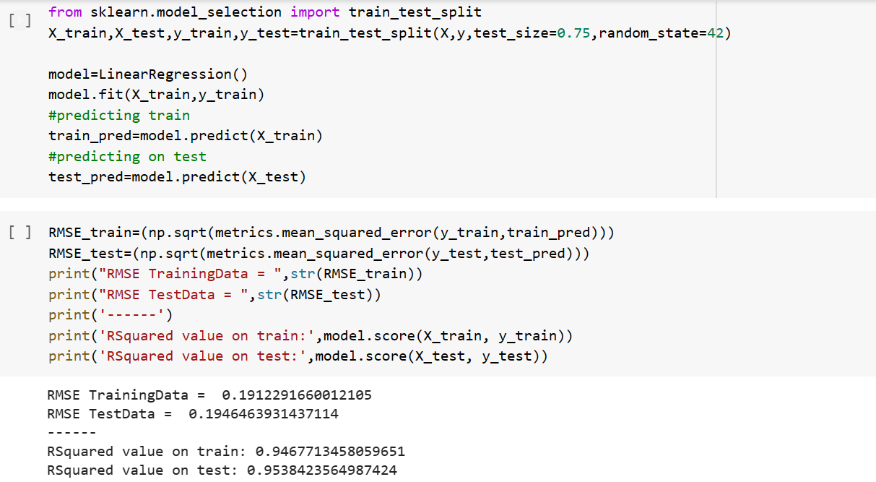

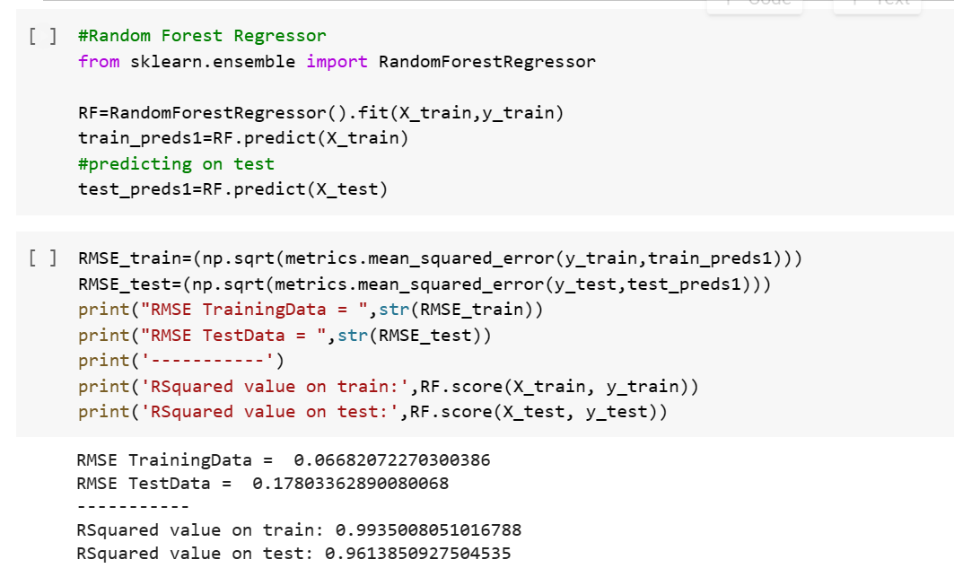

Split Ratio=0.8

Linear Regression:

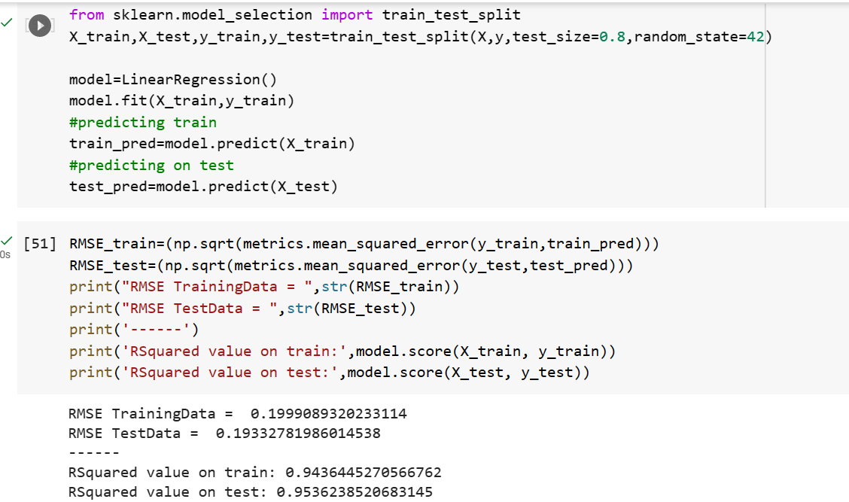

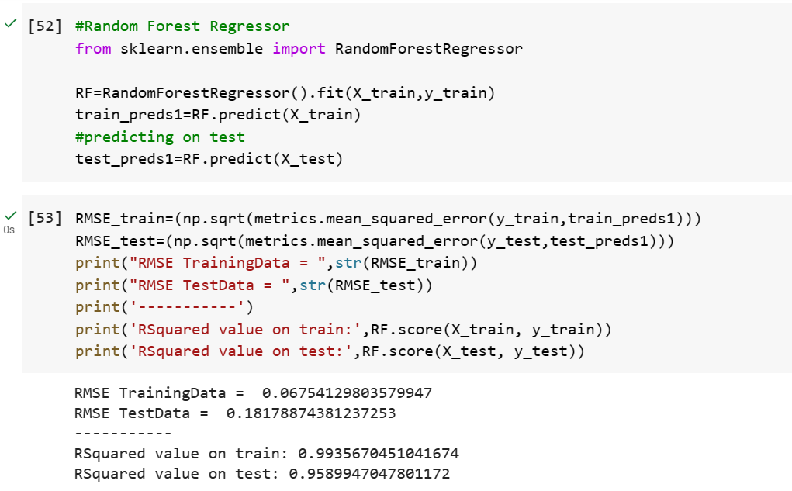

Gradient Descent Model:

Split-0.2

Linear Regression:

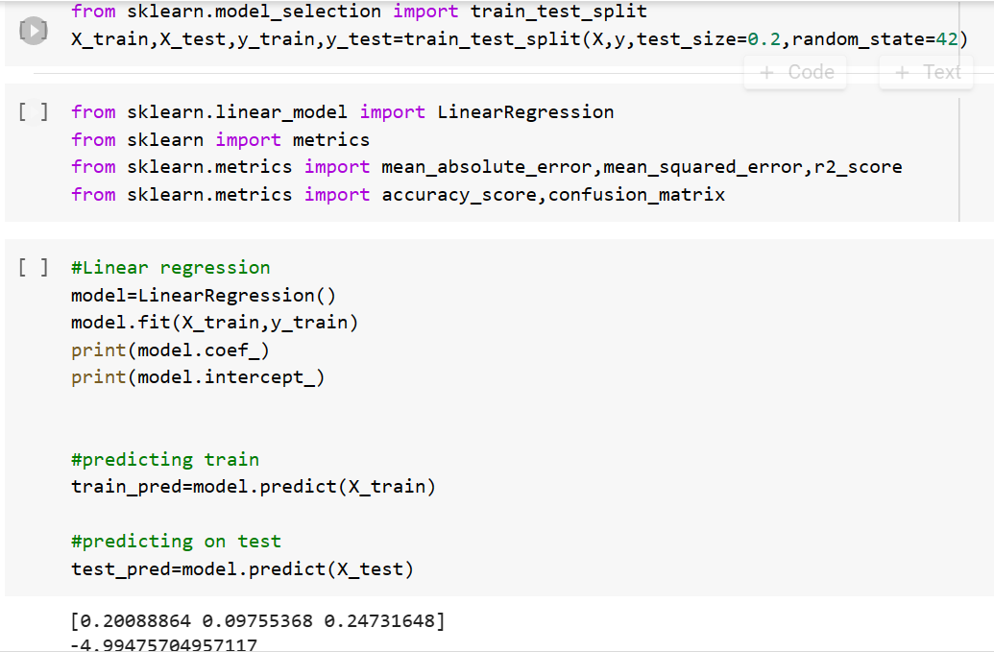

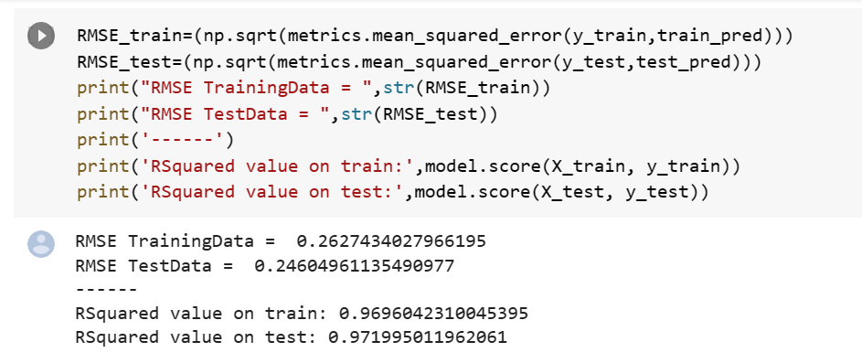

Random Forest:

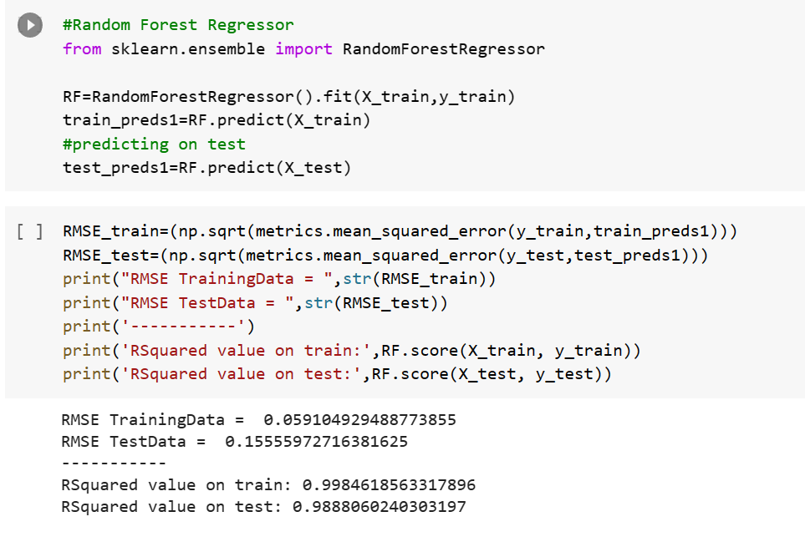

Split=0.4

Linear Regression:

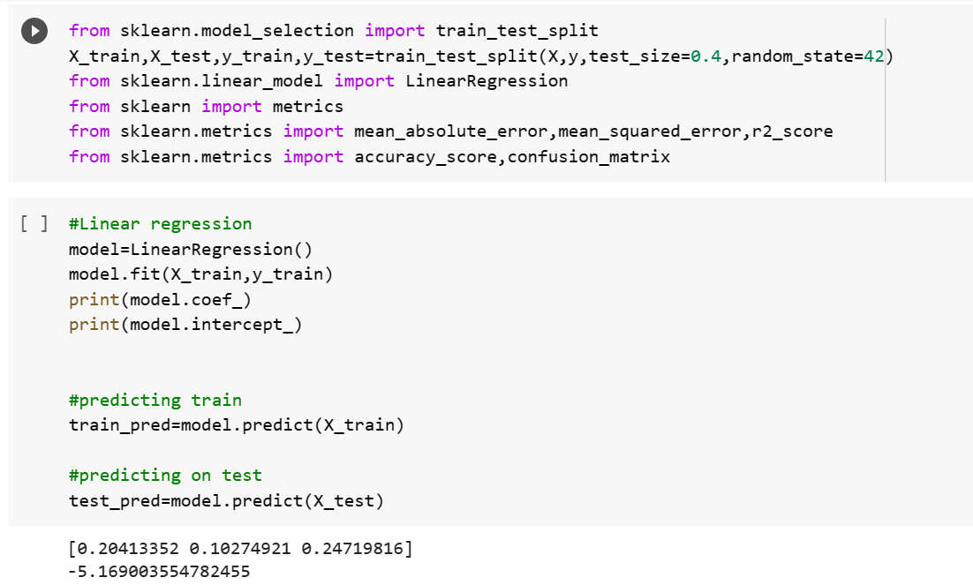

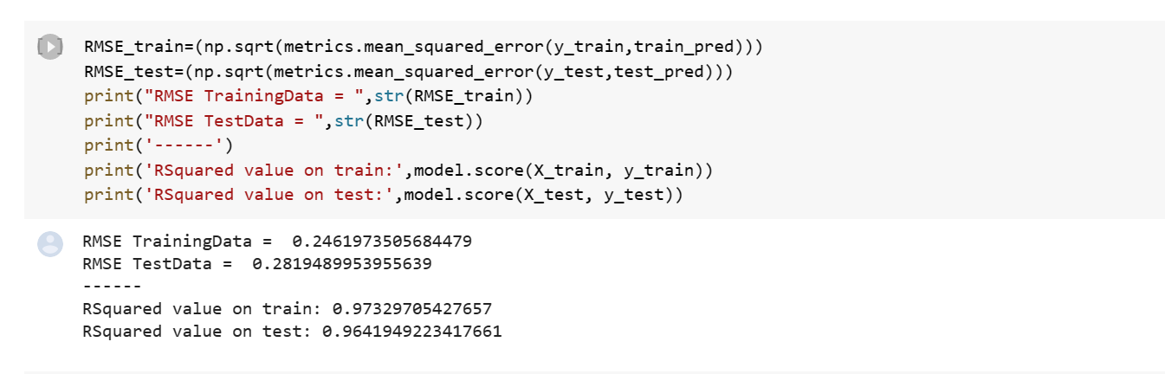

Random Forest:

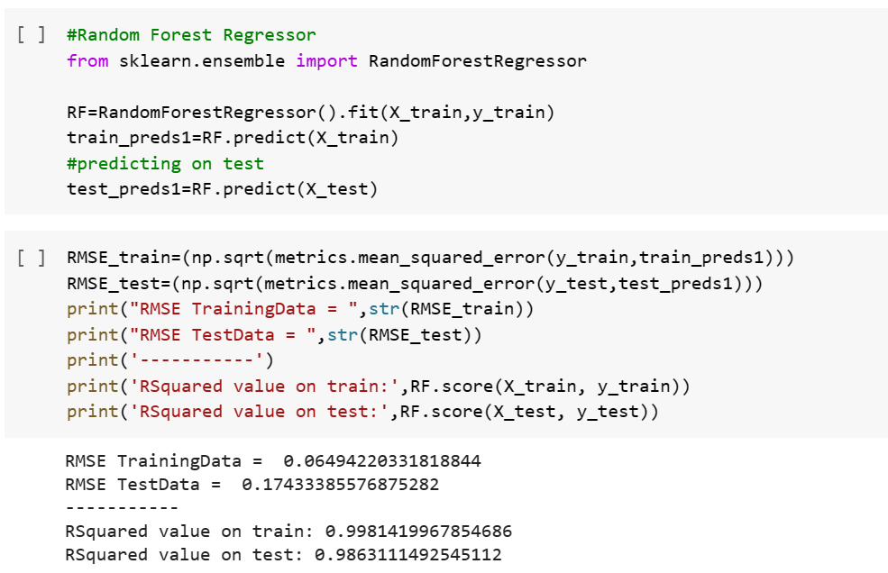

Split=0.6

Linear Regression: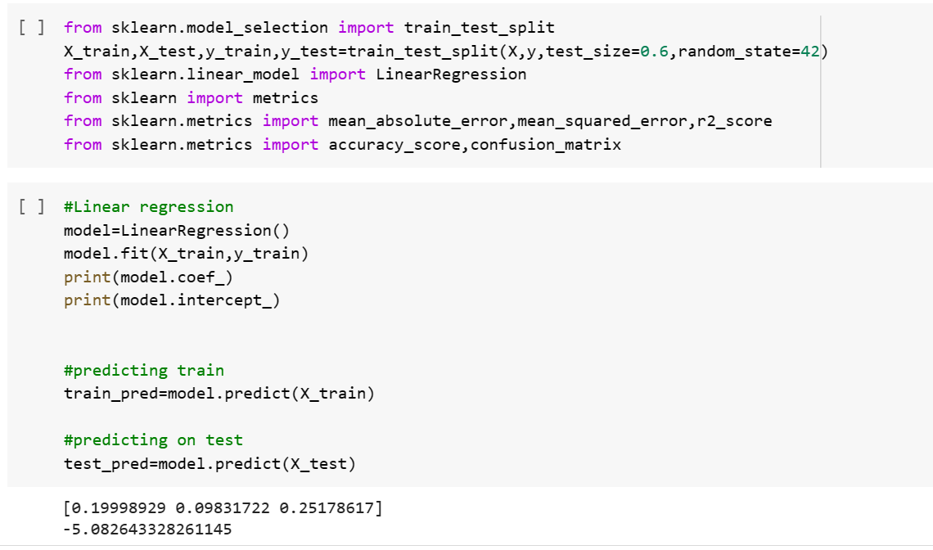

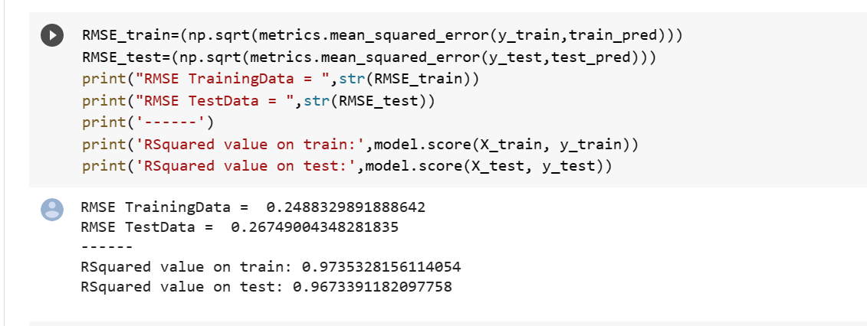

Random Forest:

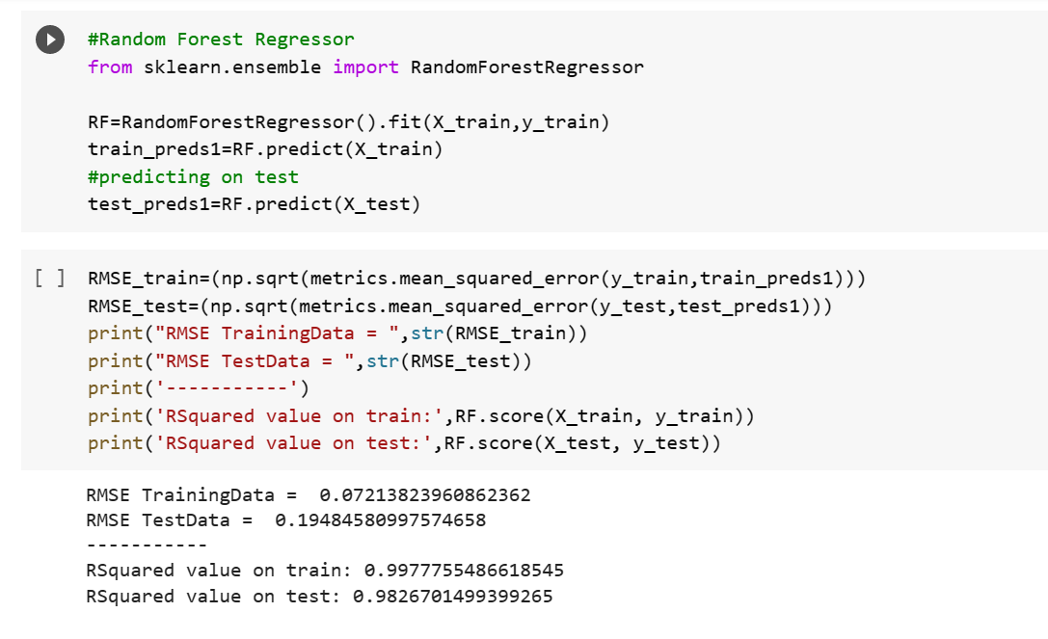

Split ratio=0.75

Linear Regression:

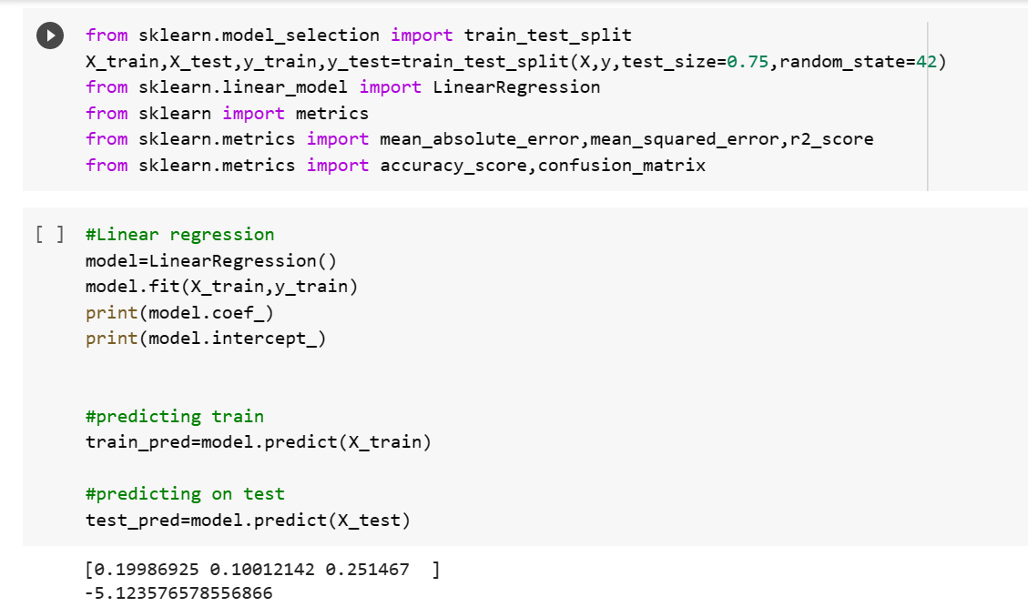

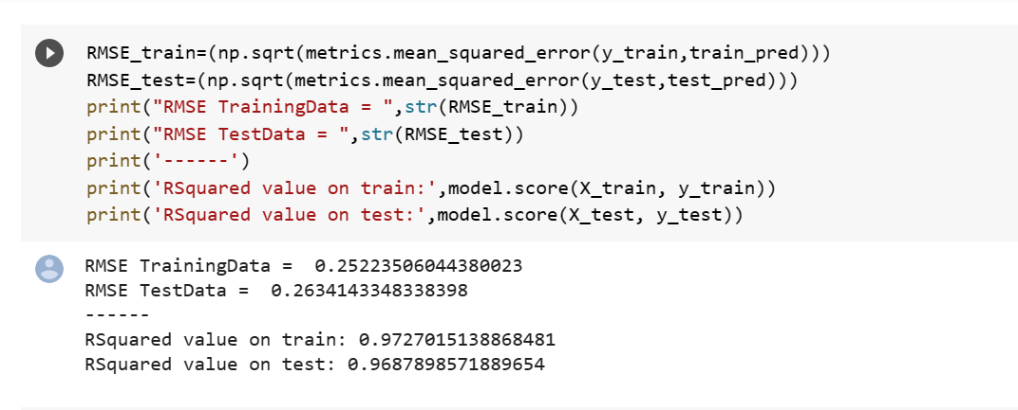

Random Forest:

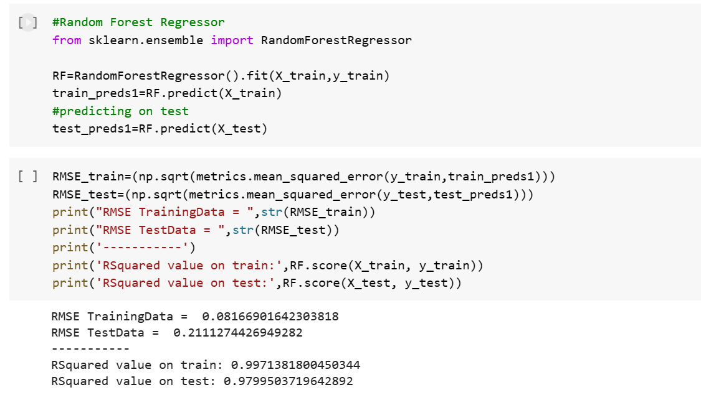

Split Ratio=0.8

Linear Regression:

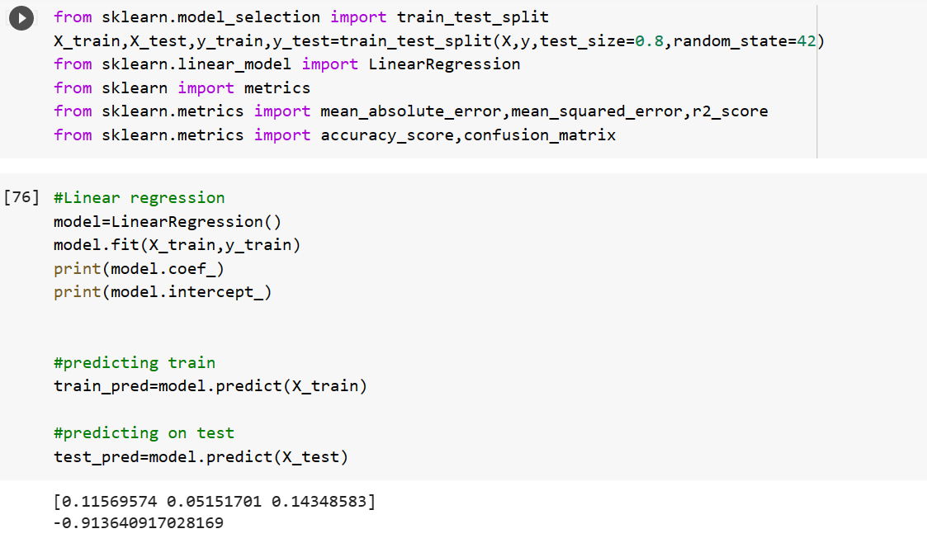

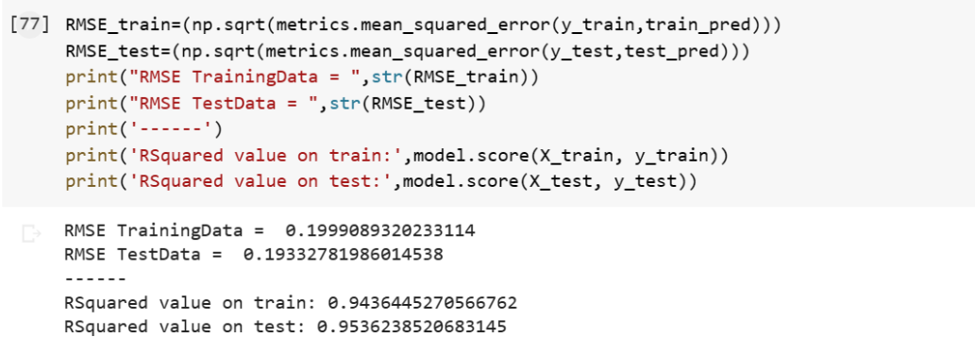

Random Forest:

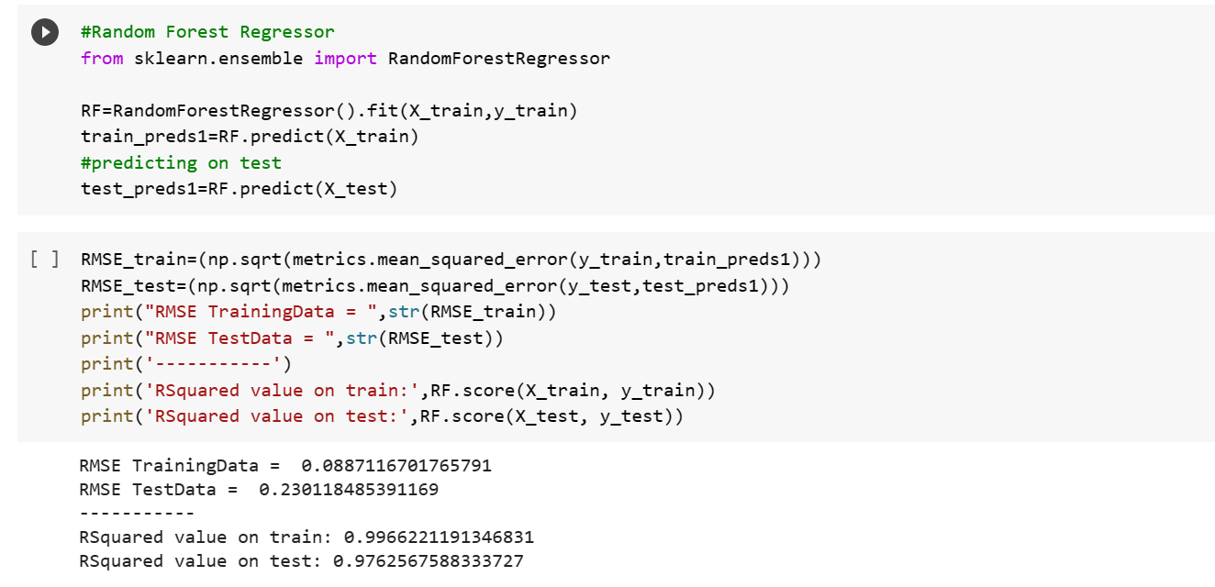

1. **CONCLUSION AND FUTURE WORKS**

Drip irrigation is one of the most effective methods of irrigation. It not only saves water but it also makes sure the water reaches the roots of the plants. It makes sure that the roots are very well hydrated and also reduces soil erosion and the growth of weeds. But even being the most effective methods, it still has its disadvantages such as clogging up easily and poor water distribution as some crops might need a lot of water and other crops might need less. It could also depend on the soil the plant is being planted and the temperature, the climate, and many other factors. All these factors can affect the drip irrigation system and the water that is needed by the crops.

Our paper suggests the calculation of crop evapotranspiration (ETO) and other crop factors so that the farmers can provide the correct amount needed for the crops. We calculate the ETO factors based on the type of soil, climate and other factors. This calculation can be used for the use of drip irrigation that can minimize the wastage of water. In this paper we have taken surveys off only on a few types of soils and included the major type of soil found in the region station for the calculation of the ETO value of the region. Furthermore, we would like to generalize the equation so that all types of soil found in India can be incorporated into the equation and an effective result could be obtained. Besides that, the variables that we incorporated into the equation are less. In the future, further variables such as the saturation vapor pressure, the actual vapor pressure and the heat flux density can be taken into consideration to improve the accuracy of the ETo value estimation. Further, the model can be improved with precise data regarding soil types from each region.

1. **REFERENCES**

1. Torres-Batlló, J., Martí-Cardona, B., & Pillco-Zolá, R. Mapping evapotranspiration, vegetation and precipitation trends in the catchment of the shrinking Lake Poopó. Remote Sensing, 12(1), 73. (2019).

2. Singandhupe, R. B. Sensitivity analysis of reference evapotranspiration ETo) models for irrigation requirement of crops and impact of irrigation on climate changes in semi-arid-regions of India. Adv. Res, 11(6), 1-16. (2017).

3. Meng, W., Sun, X., Ma, J., Guo, X., Lei, T., & Li, R. Measurement and simulation of the water storage pit irrigation trees evapotranspiration in the Loess Plateau. Agricultural Water Management, 226, 105804. (2019).

4. Khodayvandie, B., Nazemi, A. H., Shiri, J., & Trajkovic, S. Adopting regional calibration scenarios for ensuring reliable ETo estimates in semi-arid regions: assessing the ancillary data supply method. ISH Journal of Hydraulic Engineering, 28(sup1), 299-309. (2022).

5. Zhang, L., Cui, Y., Xiang, Z., Zheng, S., Traore, S., & Luo, Y. Short-term forecasting of daily crop evapotranspiration using the ‘Kc-ETo’approach and public weather forecasts. Archives of Agronomy and Soil Science, 64(7), 903-915. (2018).

6. Luo, Y., Chang, X., Peng, S., Khan, S., Wang, W., Zheng, Q., & Cai, X. Short-term forecasting of daily reference evapotranspiration using the Hargreaves–Samani model and temperature forecasts. Agricultural Water Management, 136, 42-51. (2014)

7. LIU, M. X., Yang, J. S., Li, X. M., Mei, Y. U., & Jin, W. A. N. G. Effects of irrigation water quality and drip tape arrangement on soil salinity, soil moisture distribution, and cotton yield (Gossypium hirsutum L.) under mulched drip irrigation in Xinjiang, China. Journal of Integrative Agriculture, 11(3), 502-511. (2012)

8. Berti, A., Tardivo, G., Chiaudani, A., Rech, F., & Borin, M. Assessing reference evapotranspiration by the Hargreaves method in north-eastern Italy. Agricultural Water Management, 140, 20-25. (2014)

9. Valiantzas, J. D. Simplified forms for the standardized FAO-56 Penman–Monteith reference evapotranspiration using limited weather data. Journal of Hydrology, 505, 13-23. (2013)

10. Subburayan, S., Murugappan, A., & Mohan, S. Modified Hargreaves equation for estimation of ETo in a hot and humid location in Tamilnadu State, India. International Journal of engineering science and technology, 3(1), 592-600. (2011)

11. Price, J. C. Using spatial context in satellite data to infer regional scale evapotranspiration. *IEEE transactions on Geoscience and Remote Sensing*, *28*(5), 940-948. (1990).

12. Kumar, N., Maharshi, S., Poddar, A., & Shankar, V Evaluation of Artificial Neural Networks for Estimating Reference Evapotranspiration in Western Himalayan Region. In *2020 International Conference on Computational Performance Evaluation (ComPE)* (pp. 163-167). IEEE. (2020, July).

13. Price, J. C. Estimation of regional scale evapotranspiration through analysis of satellite thermal-infrared data. *IEEE Transactions on Geoscience and Remote Sensing*, (3), 286-292. (1982).

14. Jackson, R. D. Evaluating evapotranspiration at local and regional scales. *Proceedings of the IEEE*, *73*(6), 1086-1096. (1985).

15. Bennis, I., Fouchal, H., Zytoune, O., & Aboutajdine, D. Drip irrigation system using wireless sensor networks. In *2015 federated conference on computer science and information systems (FedCSIS)* (pp. 1297-1302). IEEE. (2015, September).

16. Angaleeswari, M., Ravikumar, V., & Kannan, S. V. Evapotranspiration estimation by inverse soil water flow modelling. *Irrigation Science*, *39*(5), 633-649. (2021).

17. Han, X., Wei, Z., Zhang, B., Li, Y., Du, T., & Chen, H. Crop evapotranspiration prediction by considering dynamic change of crop coefficient and the precipitation effect in back-propagation neural network model. *Journal of Hydrology*, *596*, 126104. (2021).

18. Petković, B., Petković, D., Kuzman, B., Milovančević, M., Wakil, K., Ho, L. S., & Jermsittiparsert, K. Neuro-fuzzy estimation of reference crop evapotranspiration by neuro fuzzy logic based on weather conditions. *Computers and Electronics in Agriculture*, *173*, 105358. (2020).

19. Elbeltagi, A., Nagy, A., Mohammed, S., Pande, C. B., Kumar, M., Bhat, S. A., ... & Juhász, C. Combination of limited meteorological data for predicting reference crop evapotranspiration using artificial neural network method. *Agronomy*, *12*(2), 516. (2022).

20. Zhao, L., Zhao, X., Zhou, H., Wang, X., & Xing, X. Prediction model for daily reference crop evapotranspiration based on hybrid algorithm and principal components analysis in Southwest China. *Computers and Electronics in Agriculture*, *190*, 106424. (2021).

